# **Deliverable 2**

# **Activity Tracker**

Swapnil Srivastava, Alex Thropp, and Jonas Schulz

**Domain Model Diagram:**

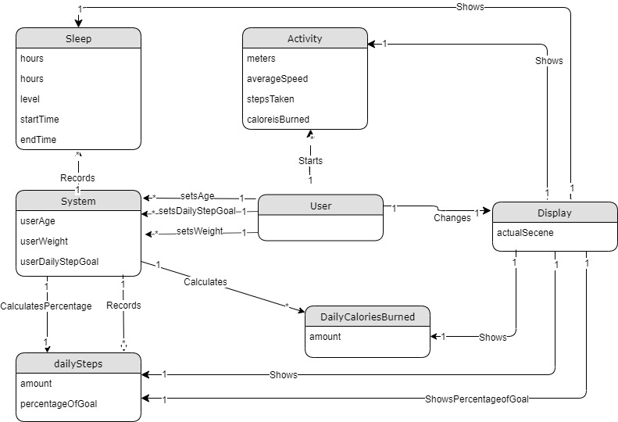

**Use Case Documentation:**

# Use case 1

Use Case: Recording activity and health

Scope: Activity tracker

Level: User goal

Primary Actor: User of activity tracker.

Stakeholders and Interests:

* User: Wants to record their activity accurately and with ease.

Preconditions: The activity tracker is paired with a phone.

Success Guarantee: Activity is recorded and saved accurately. Heart Rate is monitored and recorded accurately.

Main Success Scenario:

1. User wears the activity tracker
2. The tracker monitors and reports the heart rate of the user.
3. Tracker records the number of steps that the user takes
4. Tracker estimates the number of calories burned by the user based on the number of steps and heart rate.
5. When user sleeps, tracker monitors the quality of user’s sleep.
6. Tracker saves the day’s recorded activity and reports the activity app on paired phone.

Extensions (Alternative scenarios)

If the watch is not paired before use

1. Watch saves activity and health data for up to 1 week
2. If the phone is paired in that week, the data is shared with the phone
3. If the tracker is not paired for over 1 week, then it only saves data of the past 7 days.

Special Requirements:

* Wearable must have large text and buttons.
* The UI should be clean and easy to interact with
* The activity feedback should be in real time.

Technology and Data Variations: Wearable turned off and on by pressing and holding side button for 3 seconds.

Frequency of Occurrence: Continuous

Miscellaneous Such as open issues: Transferring data from the wearable to the smartphone app.

# Use case 2

Use Case: Accessing activity and health data

Scope: Smartphone

Level: User goal

Primary Actor: User of activity tracker.

Stakeholders and Interests: User of activity tracker.

Preconditions: The activity tracker was paired with the phone before recording activity.

Success Guarantee: Saved activity and health stats are represented in an understandable and accurate manner.

Main Success Scenario:

1. User opens the activity tracker app on their paired smartphone.
2. User can see the activity stats on the opening interface of the app
3. In the activity stats interface user accesses data on the current days activity
4. User wants to see the weekly activity so the user selects the calendar icon.
5. User can see the weekly activity in a calendar format.
6. This interface also gives user data on their health(ex: resting heart rate)
7. User clicks on the graph icon from the quick access bar to see a better visualization of this data.
8. User’s activity and health data is represented in color coded bar graph.

Special Requirements:

* Data must be color coded and easy to understand visual representation.
* Reported data must be in real time.

Frequency of Occurrence: Daily

Miscellaneous Such as open issues: Transferring data from the wearable to the smartphone app.

# Use case 3

Use Case: Monitors sleep pattern

Scope: Activity tracker

Level: System goal

Primary Actor: System of activity tracker

Stakeholders and Interests:

* User: Wants to record their activity accurately and with ease.

Preconditions: The activity tracker is paired with a phone.

Success Guarantee: Sleep activity is recorded and saved accurately. Heart Rate is monitored and recorded accurately.

Main Success Scenario:

1. The user falls asleep wearing his activity tracker (that is connected to a smartphone).
2. The phone recognizes the position and location of watch using the gyroscope (to know if user is asleep).
3. The system actively monitors heart rate,O2 levels, and movement during sleep.
4. System publishes daily report of sleep to phone for user to view

Special Requirements:

* Wearable must be on for sleep.
* The sleep activity feedback should be available in real time.

Frequency of Occurrence: Nightly

Miscellaneous Such as open issues: Transferring data from the wearable to the smartphone app.

# Use case 4

Use Case: View sleep patterns

Scope: Activity tracker

Level: User goal

Primary Actor: User of activity tracker.

Stakeholders and Interests:

* User: Wants to view their activity accurately and with ease.

Preconditions: The activity tracker is paired with a phone.

Success Guarantee: Activity is viewed accurately.

Main Success Scenario:

1. User opens smart phone app
2. The user clicks on button/tab pertaining to sleep patterns
3. Once clicked the app will display the data dealing with last nights sleep activity
4. The user will have the option to view the last 7 days as a whole to see how they slept throughout the week.

Extensions (Alternative scenarios)

If the watch is not paired before use

1. User opens smart phone app
2. The user clicks on button/tab pertaining to sleep patterns
3. Once clicked the app will display the data dealing with last nights sleep activity
4. The user will only be allowed to view the most recent 7 days from the last sync.

Special Requirements:

* Wearable must be connected to phone
* The UI should be clean and easy to interact with
* The activity feedback should be in real time.

Frequency of Occurrence: daily

Miscellaneous Such as open issues: Transferring data from the wearable to the smartphone app.

# Use case 5

# Use Case: Use wants to view date/time from initial watch face

Scope: Activity tracker

Level: User goal

Primary Actor: User of activity tracker.

Stakeholders and Interests:

* User: Wants to view information accurately and with ease.

Preconditions: The activity tracker is paired with a phone.

Success Guarantee: Date and time is viewed from watch face.

Main Success Scenario:

1. The user raises the watch to viewing height
2. The user turns on the display.
3. Using the gyroscope the system will look to see if the watched is angled correctly (left to right)
4. The system will display the date and time to the user on the from of the watch face

Special Requirements:

* Wearable must have large text and buttons.
* The UI should be clean and easy to interact with
* The activity feedback should be in real time.

Frequency of Occurrence: Continuous

Miscellaneous Such as open issues: Transferring data from the wearable to the smartphone app.

# Use case 6

Use Case: view steps

Scope: Activity tracker

Level: User goal

Primary Actor: User of activity tracker.

Stakeholders and Interests:

* User: Wants to view their activity accurately and with ease.

Preconditions: The activity tracker is paired with a phone.

Success Guarantee: step count viewed on face of watch

Main Success Scenario:

1. The user raises the watch to viewing height
2. The users stick out their arm manipulating the watch to an up to down position. (checked by sys gyroscope)
3. The users turns on the display
4. The step count is displayed on the face of the watch

Special Requirements:

* Wearable must have large text and buttons.
* The UI should be clean and easy to interact with
* The activity feedback should be in real time.

Frequency of Occurrence: Continuous

Miscellaneous Such as open issues: Transferring data from the wearable to the smartphone app.

# Use case 7

Use Case: the user wants to access/change the settings

Scope: Activity tracker

Level: User goal

Primary Actor: User of activity tracker.

Stakeholders and Interests:

* User: access or change settings from the watch

Success Guarantee: user reaches settings and can change desired setting.

Main Success Scenario:

1. User turns on the display
2. The user goes to the home screen and selects the settings button
3. Once in the settings menu the user can choose to change date/time as well as the units of measure etc.

Extensions (Alternative scenarios)

If the watch is paired before use

1. The user opens the smartphone app
2. The user selects myActivityTracker
3. The users selects “customize”
4. The user now has the same functionality as they would have in the device itself.

Special Requirements:

* Wearable must have large text and buttons.
* The UI should be clean and easy to interact with
* The activity feedback should be in real time.

Frequency of Occurrence: daily

Miscellaneous Such as open issues: Transferring data from the wearable to the smartphone app.

# Use case 8

Use Case: user sets age

Scope: Activity tracker

Level: User goal

Primary Actor: User of activity tracker.

Stakeholders and Interests:

* User: Wants to record their age accurately and with ease.

Success Guarantee: age is recorded and saved accurately.

Main Success Scenario:

1. User turns on the display
2. The user goes to the home screen and selects the settings button
3. Once in the settings menu the user can choose to change age
4. The user can select age from an on screen buttons

Special Requirements:

* Wearable must have large text and buttons.
* The UI should be clean and easy to interact with
* The activity feedback should be in real time.

Technology and Data Variations: Wearable turned off and on by pressing and holding side button for 3 seconds.

Frequency of Occurrence: Continuous

# Use case 9

Use Case: user sets daily step goals

Scope: Activity tracker

Level: User goal

Primary Actor: User of activity tracker.

Stakeholders and Interests:

* User: Wants to record their daily step goal accurately and with ease.

Success Guarantee: daily step goal is recorded and saved accurately.

Main Success Scenario:

1. User turns on the display
2. The user goes to the home screen and selects the settings button
3. Once in the settings menu the user can choose to change daily step goal
4. The user can select daily step goal from an on screen buttons

Special Requirements:

* Wearable must have large text and buttons.
* The UI should be clean and easy to interact with
* The activity feedback should be in real time.

Technology and Data Variations: Wearable turned off and on by pressing and holding side button for 3 seconds.

Frequency of Occurrence: Continuous

# Use case 10

Use Case: user sets weight

Scope: Activity tracker

Level: User goal

Primary Actor: User of activity tracker.

Stakeholders and Interests:

* User: Wants to record their weight accurately and with ease.

Success Guarantee: weight is recorded and saved accurately.

Main Success Scenario:

1. User turns on the display
2. The user goes to the home screen and selects the settings button
3. Once in the settings menu the user can choose to change weight
4. The user can select their weight from an on screen buttons

Special Requirements:

* Wearable must have large text and buttons.
* The UI should be clean and easy to interact with
* The activity feedback should be in real time.

Technology and Data Variations: Wearable turned off and on by pressing and holding side button for 3 seconds.

Frequency of Occurrence: Continuous